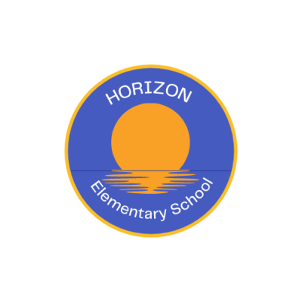

May 16, 2022
Hello Families of Primary Students 2022-23,

Welcome to Horizon Elementary! Our administration team consists of Tara Rutledge (vice principal), Marlene MacKenzie (administrative assistant) and me, Nancy Liberatore (principal). Our school phone number is 902-465-8651 or you can reach us via email. You can obtain staff email addresses and phone extensions, along with other pertinent information on our school web site: https://hes.hrce.ca/.
Starting school is an exciting time for your family. I want to prepare you, as much as possible, for what schooling will look like for your child. September is a busy month and being well-informed in advance may help ease some of the stress and anxiety that comes with building new routines. We will be holding an in-person primary orientation on Wednesday, June 1st. Students attending primary English are invited to join us at 8:45-9:30 AM. Students attending primary French Immersion are invited to join us at 10:00-10:45 AM.

Teachers will meet families at DOOR #2 and take the children to their classroom. I will share information with parents outside the main entrance of the school fifteen minutes prior to the end of each session (9:15 AM & 10:30 AM). I will also take any questions you may have.

I look forward to meeting you and working with you and your child. If possible, any pre-school experiences you can provide your child such as: holding a pencil, coloring, practicing the letters of the alphabet, listening to stories and cutting out shapes and gluing them to paper would be helpful as they transition to grade primary. Please read often with your child and talk about the pictures in the book, ask questions about the story, have them tell you what they wonder about in the story and their favorite part of the story. These routines will help your child develop a love of reading as well as develop their vocabulary and reading comprehension strategies.
At Horizon Elementary our objective is to ensure every student has access to an equitable and high-quality education that is culturally and linguistically responsive, accepting, and respectful in supporting and valuing each student, their learning and diverse abilities.

Please join us on Wednesday, June 1st for primary orientation. If you are not able to join us at that time, I will share the information with all families in an email. If your child currently attends pre-primary, and you are not able to make it, I will ask pre-primary staff to bring your child to the classroom of the program in which they are registered.

I look forward to making your child’s time at Horizon Elementary an enjoyable and rewarding learning experience.

Sincerely,
Nancy Liberatore
nliberatore@hrce.ca
902-465-8651 ext. 2
PJILA’SI
BIENVENUE
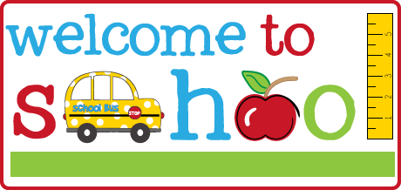
Helpful Links:
Welcome to Primary https://sites.google.com/gnspes.ca/welcometothehrce/welcome-to-primary?authuser=0

French Second Language Programs https://www.hrce.ca/sites/default/files/hrsb/Departments/SchoolAdmin/french_second_language_brochure_2021.pdf

https://www.hrce.ca/registration

