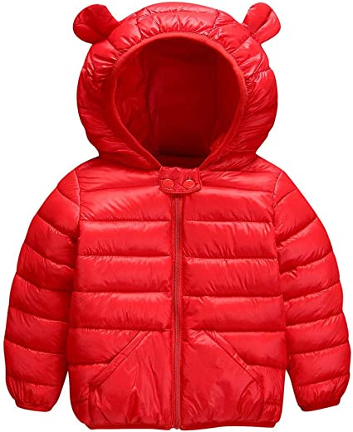
Good Evening Horizon Families,
Now that the colder weather is here, it is time to get out the winter coats, jackets, hats, mittens, scarves, and boots. Please write your child's name on their outerwear. Students do not always recognize their own clothing. Soon we will have at least 150 pairs of black snow pants in the school, and it will be difficult to discern who owns what, if there is no name on the pants. Trust me, it happens every winter. :)
The Lost and Found is overflowing with hoodies and sweatshirts without names on them. Please check the lost and found outside the music room when you are at the school.
Attached is the wind chill safety protocol for your information.
Thank you,
Nancy

